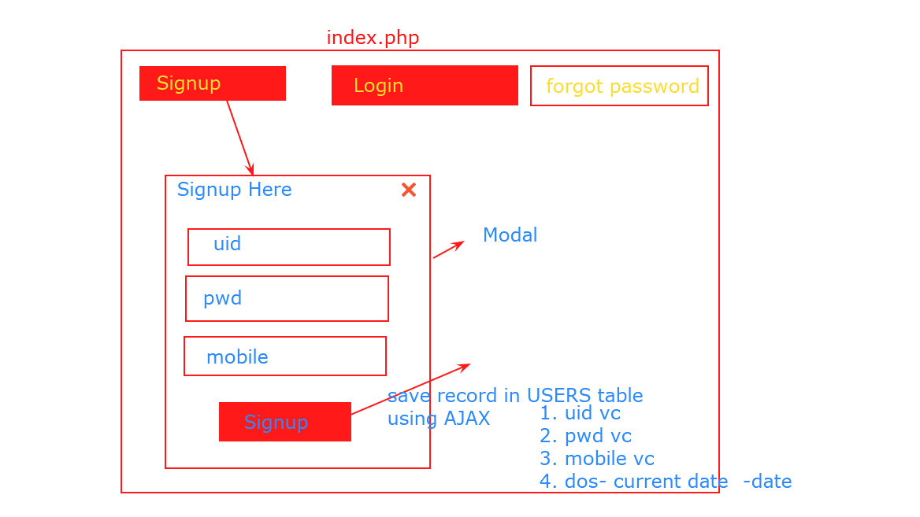

Using AJAX check UID and PWD in USERS table.

Show Message: Authorized or Unauthorized

LOGIN

password

Uid

**LOGIN HERE**